**Comments from Visitors and Parents**

‘So pleased with his progress and my son has enjoyed his time here and he is all ready for school from his support and encouragement from Gill Blowers’

‘It is so lovely to see how much progress A has made because of all of you. We will be very sad to say goodbye to everyone when A goes to school soon. Thankyou all so much for being part of A’s life, you taught her so much and you were always there for us.

We will miss you!

‘Really happy and thankful to the teachers and staff for his overall development and I can’t thank them enough.

‘I am so pleased in how far my son has progressed in Gill Blowers, the staff are amazing and I feel thankful to have them teach my son, such a lovely place.

Thankyou for all your help and support. Your amazing Gill Blowers’

‘I enjoyed attending Wow Wednesdays with my child as it helps me understand what shes learning at nursery’

‘It was fun and good to see how nursery can organise a great day for children’

‘I am happy with the nursery and their teaching’

‘I did join few wow Wednesday’s and curriculum days. I really enjoyed it and S love’s all the activities’

The WOW Wednesday is a good activity to enjoy with my child at his nursery.To see what he is doing during the day and taking new crafts home to do’

‘Wow Wednesday is very good. It’s nice to see all the children playing together’

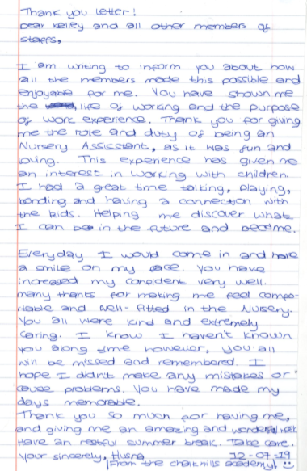

‘She really enjoyed doing them (wow Wednesdays) with me, seen a different child in her’

