Wow Wednesday Planning
Come and join your child each Wednesday in class. 10.45am and 2.45pm
Week | Activity
1 - 31st October 2019 | ‘Celebrating Diwali  Come and create Rangoli patterns  EAD Media & Materials: 30-50m Understands that they can use lines to enclose a space,  and then begin to use these shapes to represent objects.
2 - 6th November 2019 | ‘Firework painting’  Come and make a bang in the garden and create a huge firework picture.  EAD Media & Materials: 30-50m Explores colour and how colours can be changed.
3 - 13th November 2019 | Cheese Cake’  Cooking cheese based cakes  MATHS Number 30-50m Shows curiosity about numbers by offering comments or asking questions.
4 -20th November 2019  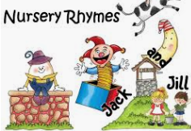 | ‘Nursery Rhyme week’  Join us to sing nursery rhymes as a group.  Leabank in class, Mossdale around the camp fire.  EAD Exploring & using media & materials 30-50m • Enjoys joining in with dancing and ring games. /  Sings a few familiar songs. / Beginning to move rhythmically.
5 - 27th November 2019  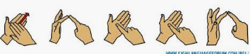 | ‘Phonics fun’  Learn how to finger spell the letters of the alphabet  LIT Reading & Writing: 40-60m Links sounds to letters, naming and sounding the letters  of the alphabet.
6- 4th December 2019  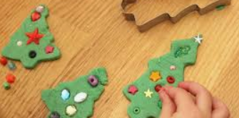 | ‘Christmas Playdough’  Make some Christmas playdough to take home  EAD Exploring & using media & materials 30-50m Beginning to be interested in and describe  the texture of things.
7- FRIDAY 13th Dec | ‘Curriculum Day’  Christmas performance and other exciting activities.  EAD Exploring & using media & materials 30-50m • Enjoys joining in with dancing and ring games. /  Sings a few familiar songs. / Beginning to move rhythmically.
8 -18th December 2019 | ‘It’s Christmas’  Come and decorate natural objects to turn them into Christmas decorations.  EAD Media & Materials: 30-50m Explores colour and how colours can be changed.

