Wow Wednesday Planning
Come and join your child each Wednesday in class. 10.45am and 2.45pm
Week | Activity
1  3rd June  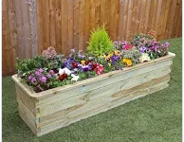 | ‘Make Gill Blowers Bloom’  Planting and watering in the garden.  UW The World: 30-50m Can talk about some of the things they have observed such as plants, animals, natural and found objects.  ELG:They make observations of animals & plants& explain why some things occur,  & talk about changes.
2  10th June  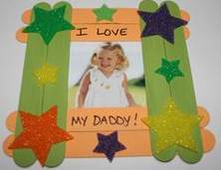 | ‘Father’s Day’  Making pizza and presents for dad.  Dads and male relatives are especially welcome  EAD Media & Materials: 30-50m Understands that they can use lines to enclose a space,  and then begin to use these shapes to represent objects.  ELG: They safely use & explore a variety of materials, tools & techniques, experimenting with  colour, design, texture, form & function
3  19th June | ‘Sports Day and Picnic’  Join us on the field for fitness fun and food.  More details to follow.  PD Moving and handling: 30- 50m Moves freely and with pleasure and confidence in a range  of ways,such as slithering, shuffling, rolling, crawling, walking, running, jumping, skipping,  sliding and hopping.  ELG: Children show good control &co‐ordination in large & small movements. They move  confidently in a range of ways, safely negotiating space
4  26th June  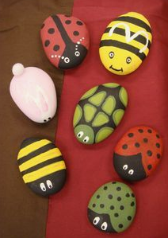 | ‘Stone painting’  Making bugs and fairies from stones for the garden at home and nursery.  EAD Media & Materials: 30-50m Understands that they can use lines to enclose a space,  and then begin to use these shapes to represent objects.  ELG: They safely use & explore a variety of materials, tools & techniques, experimenting with  colour, design, texture, form & function
5  3rd July  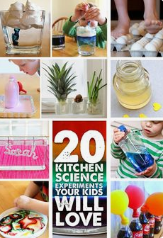 | ‘Experiments’  Make playdough and kinetic sand to take home as well as taking part in exciting science experiments  UW The World: 30-50m Can talk about some of the things they have observed such as plants, animals, natural and found objects.  ELG:They make observations of animals & plants& explain why some things occur,  & talk about changes.
6  10th July  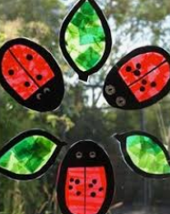 | ‘Stain Glass Bugs’  Brighten up the windows with summer bugs.  EAD Media & Materials: 30-50m Understands that they can use lines to enclose a space,  and then begin to use these shapes to represent objects.  ELG: They safely use & explore a variety of materials, tools & techniques, experimenting with  colour, design, texture, form & function
7  17th July | ‘School Trip to Paradise Wildlife Park’  More details to follow.  UW The World: 30-50m Can talk about some of the things they have observed such as plants, animals, natural and found objects.  ELG:They make observations of animals & plants& explain why some things occur,  & talk about changes.

