Wow Wednesday Planning
Come and join your child each Wednesday in class. 11am and 2.30pm
Week | Activity
1 – 8th January 2020  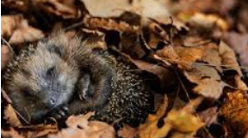 | ‘Hibernation Homes’  Come and help the cold animals keep warm as they hibernate.  UW The World 30-50m Shows care and concern for living things and the  environment.
2 - 15th January 2020  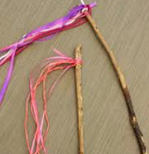 | ‘Wind Wands’  Come and make beautiful wind wands.  UW The World 30-50m Talks about why things happen and how things work.
3 – 22nd January 2020  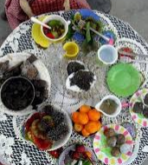 | ‘Leafy Tea Party’  Come and have a tea party with your child in the mud kitchen  EAD Being Imaginative 30-50m Engages in imaginative role‐play based  on own first‐hand experiences.
4 -29th January 2020  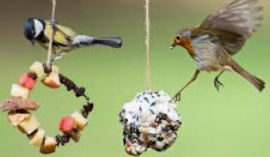 | ‘Bird feeders’  Join us and make bird feeders in class on Wednesday, then, on Friday help us to place them out in the environment near to nursery.  .  UW The World 30-50m Shows care and concern for living things and the  environment.
5 – 5th February 2020  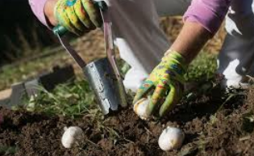 | ‘Planting’  Help brighten up the nursery garden by planting seasonal flowers and plants.  UW The World 30-50m Can talk about some of the things they have observed  such as plants, animals, natural and found objects.
6- 12th February 2020  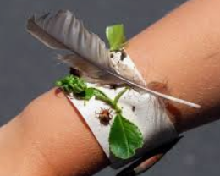 | ‘Leafy accessories’  Make bracelets and necklaces from natural resources to take home  EAD Exploring & using media & materials 30-50m Beginning to be  interested in and describe the texture of things.
Please be aware that some activities may differ slightly in the 2-3 room at Leabank. Please check with staff for any changes.

