

***GILL BLOWERS NEWSLETTER***

***Mossdale***

***Head Teacher Message:*** This year has been wonderful for all of us at Gill Blowers, having your children back in school has been fabulous.

It has been a big adjustment for the children after the past couple of years but they have coped brilliantly and have enjoyed making friends, exploring the environment and learning new skills. We are very proud of all the children.

As you know Gill Blowers has now federated with Pastures Way Nursery School, it is an exciting time which both schools will benefit from.

For the children moving onto school in September, this can be an exciting but anxious time for them and for you as parents /carers. The staff have been working with our feeder schools to ensure the transitions are as smooth as possible. They have been doing lots of work in the classroom to prepare the children for the expectations of their new schools. We are sad to say goodbye to your children and will miss them but we know they are ready for the next part of their journey.

For your children that are remaining with us, we look forward to welcoming them back in September.

At this time of year, staff may be tired, but, they are also excited about the new term and the plans they have put into place to ensure the children have a fabulous start to the new school year.

On behalf of the staff and Governors I would like to thank you for your support over the past year and hope you have a good summer break with your amazing children.

Finally, I would like to say a fond farewell to Nina (Business Manager) and Steph (practitioner at Leabank) as they move on to new roles. We all wish them both well and will miss them very much. I would also like to welcome Sue, our new Assistant Head, Sue will be based at Pastures Way but will be working across the Federation. Take Care Jo Iddenden

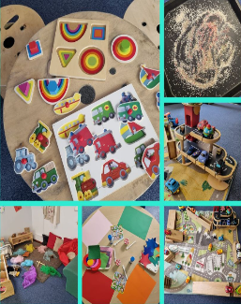

***A message from the family worker Team:***

Marie and Lisa have had a very busy half term.  Parents have joined us on walks and picnics, and we were blessed with some lovely weather.

We have also been supporting taking the children to have a look at their new schools.

Stay and plays are up and running again 9 – 10am Leabank and 12.30 – 13.30pm Mossdale just £1 per family.  These will continue when we come back in September.

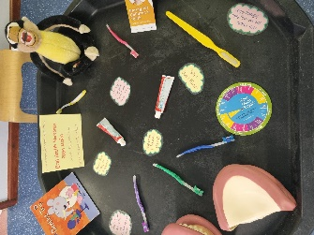

**Term Dates:**

Last day of term: Wed 20th July ‘22

Children return Wed 7th Sept’22

Half term 24th-28th Oct’22

Last day of Autumn Term:

Friday 16th Dec ’22

**Follow us on Facebook and Instagram to keep updated on what we are up to…**



**Term Dates:**

***What have we been up to?***



The blender was very loud

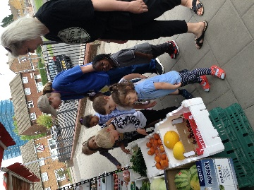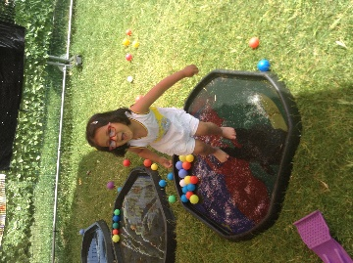

***2-3 room ‘Daisy Class***

2-3's Daisy Class have been busy this term .The children have been exploring natural materials in the sensory kitchen and mixing things together.

We've enjoyed using our garden as a splash park on hot days and having our group stories out in the sunshine.

For Healthy eating week we went to the shops to purchase fruit which we cut up to make delicious smoothies for snack time, For fathers’ day we went to the wooden park with some of our Mummies and Daddies coming to play too.

Hope you all have lovely Summer Holidays and we look forward to seeing you in September.

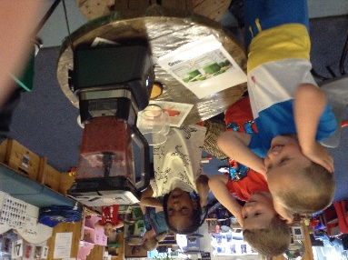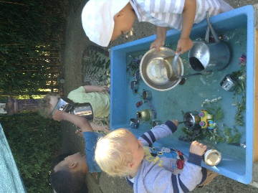

***School Updates:***

We look forward to seeing you for ***Achievement Day on Friday 15th July*** and remind you there are End of term parties on Tuesday 19th July.

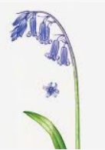

Is it a unicorn egg?

Will there be a puppy?



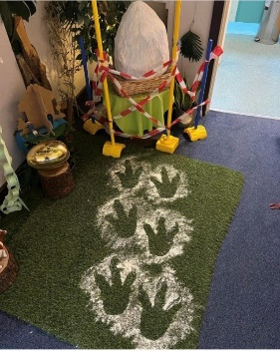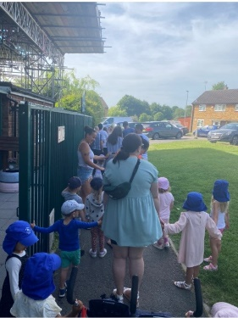

***3-4 room ‘Bluebell Class’***

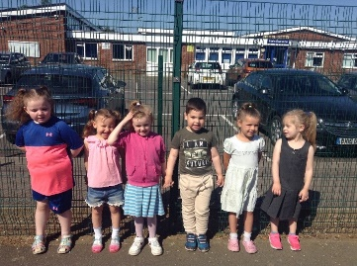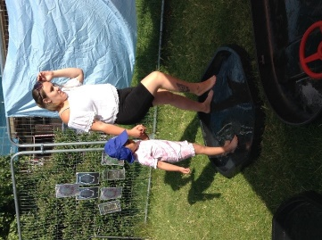

Bluebell class have been very busy this half term. We found a giant egg in our classroom which led to lots of imaginative talk. We had clues along the way to help us guess it was a dinosaur egg! We welcomed lots of special people to walk with us or join us for our stay and play for Father’s Day. During the warmer weather we’ve had fun splashing around in the garden. Our older children have been doing lots of activities in preparation for Big school.